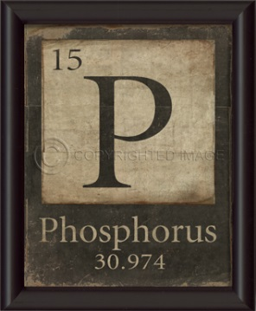
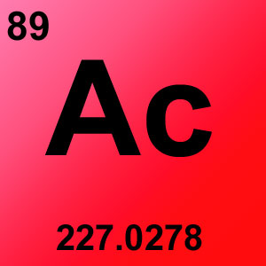
Chemistry Syllabus
2018-2019

What do I need?

- paper
- scientific calculator
- pencil/pen
- binder or folder (with all handouts)
- chromebook
- earbuds

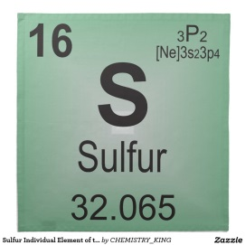
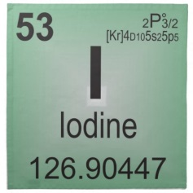
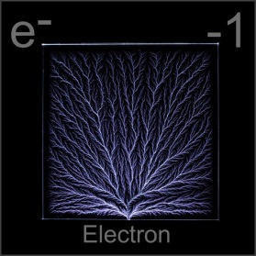
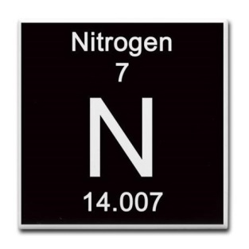
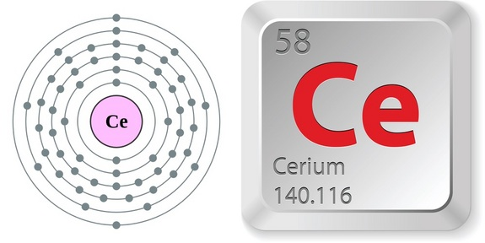
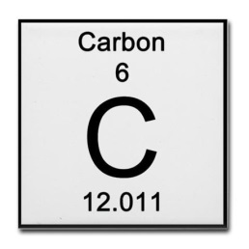
What will I learn?

- Scientific Method
- Measurement
- Matter and Energy
- Structure of the Atom
- Quantum Theory
- The Periodic Table
- The Elements
- Ionic Compounds
- Covalent Bonding
- Nomenclature
- Chemical Reactions
- The Mole
- Stoichiometry
- Thermochemistry
- States of Matter
- Solutions
- Acids and Bases

What are the classroom rules?
Grading Scale
- Be prepared for class
100%-93%---A
92%-90%---A-
89%-87%---B+
86%-83%---B
82%-80%---B-
79%-77%---C+
76%-73%---C
72%-70%---C-
69%-67%---D+
66%-63%---D
62%-60%---D-
59%-0%-----F

- Respect others and their property
- Follow all safety rules

Do we have a textbook?
We will have a classroom set of textbooks that you can use when you are in class. If you would like a textbook to take home, you may check one out with Mrs. Davis

What about Homework and Tests?
Some homework will be graded and some will be optional. Tests can be retaken or alternate assessments can be given. Please see homework policy and alternate assessment/retest policy.

What if I don’t get my work done?
Late work usually will not be accepted because we go over assignments in class or other students will already have graded work returned.

What if I am gone?
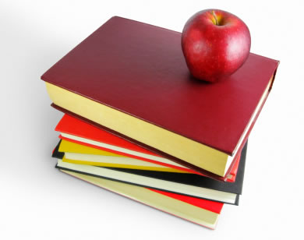
When you are absent from school, it is important to make up your work as soon as possible so that you do not fall behind. When you come back to class, you will receive a slip of paper, which tells you what you missed. You may also check my website or email me to see what you have missed.

How do I get help?
mdavis@pacsd.org
http://mlyndavis.weebly.com/
Come in during my free period
Come in before or after school
Come in during tribes

